**Week 5 -Microservices with Spring Boot 3 and Spring Cloud**

**Creating Microservices for account and loan**

**Account Microservice:**

AccountController.java

package com.cognizent.account.controller;

import org.springframework.web.bind.annotation.*;

import java.util.Map;

*@RestController*

*@RequestMapping*("/accounts")

public class AccountController {

*@GetMapping*("/{number}")

public Map<String, Object> getAccountDetails(*@PathVariable* String number) {

return Map.*of*(

"number", number,

"type", "savings",

"balance", 234343

);

}

}

**Output**

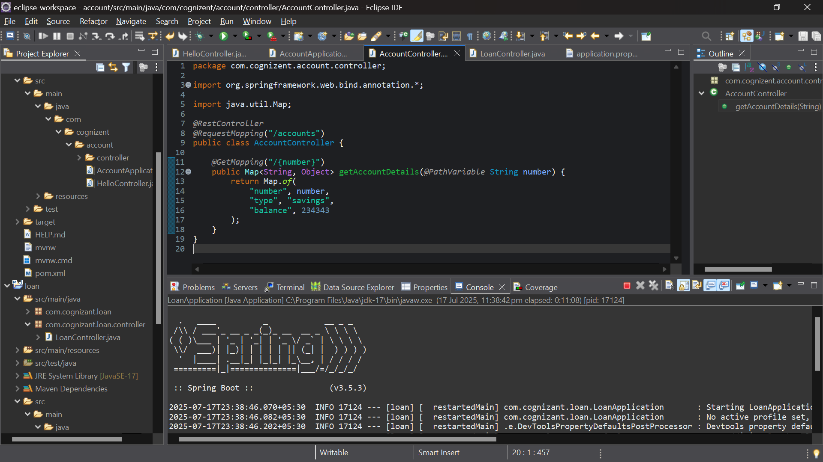

**Loan Microservice:**

**LoanController.java**

package com.cognizant.loan.controller;

import org.springframework.web.bind.annotation.*;

import java.util.Map;

*@RestController*

*@RequestMapping*("/loans")

public class LoanController {

*@GetMapping*("/{number}")

public Map<String, Object> getLoanDetails(*@PathVariable* String number) {

return Map.*of*(

"number", number,

"type", "car",

"loan", 400000,

"emi", 3258,

"tenure", 18

);

}

}

**Output:**

